**minh họa câu trả lời PT1**

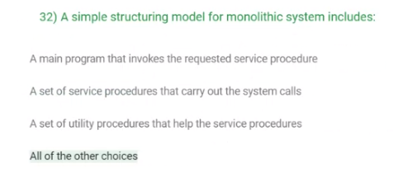

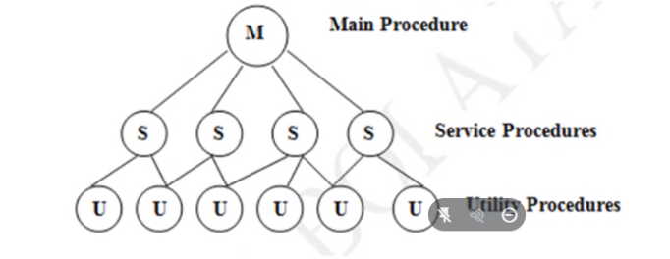

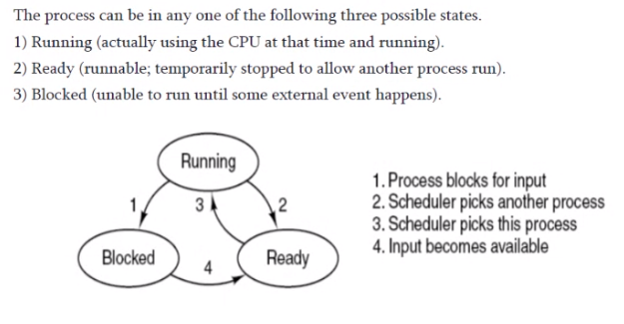



* **Answer: Kernel level, User, K supported**

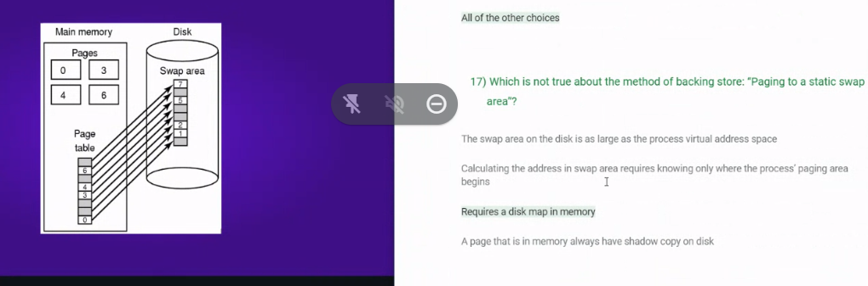

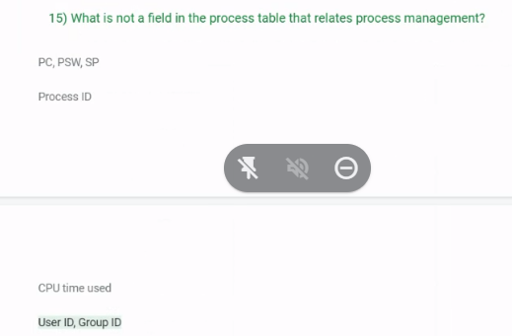

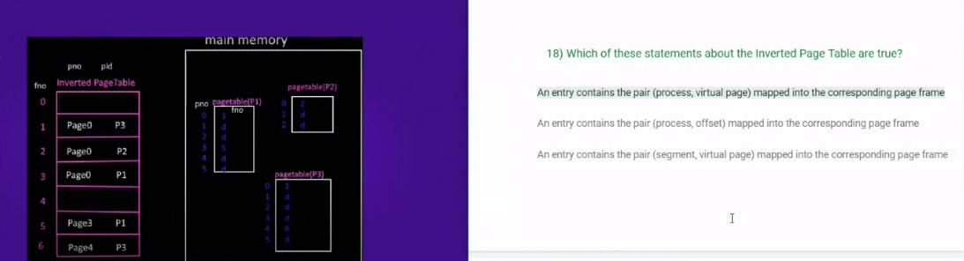

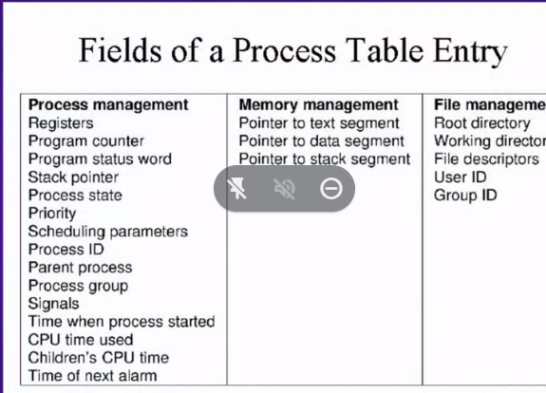

caches: thg doc 1 byter: 1 ns= 10-6

* 1 char=1 byte
* 1000 pages*25lines*80 chars= 2*106 bytes
* Tg doc het 1 cuon sach: 2*106*10-6= **2ms**
* Tuong tu:
* RAM: tg doc 1 byte : 10ns=10-8
* Tg doc het 1 cuon sach: 2*106*10-8= =2*10-2 (s)=**20(ms)**
* Disk: 5 ms de truy cap 1000 bytes, toc do doc 1 bytes= 5.10-3
* Tg doc het 1 cuon sach: 2*106*5*10-3= **10s**

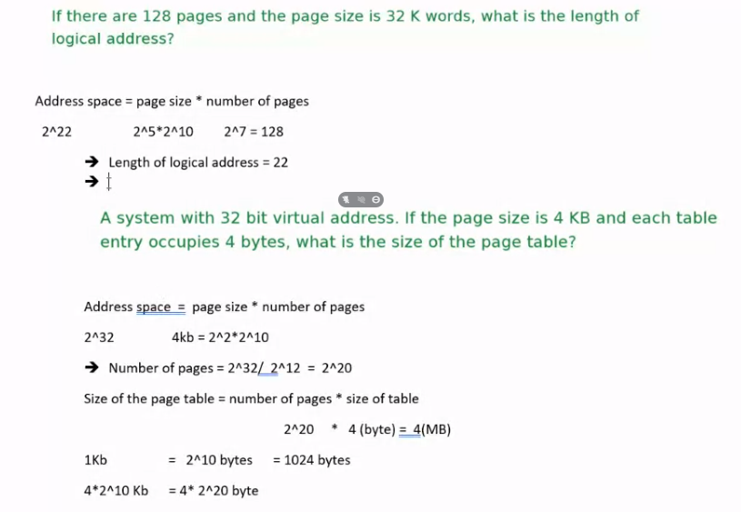

**Bai 1: Thuat toan 1: FCFS tinh thoi gian quay vong trung binh**

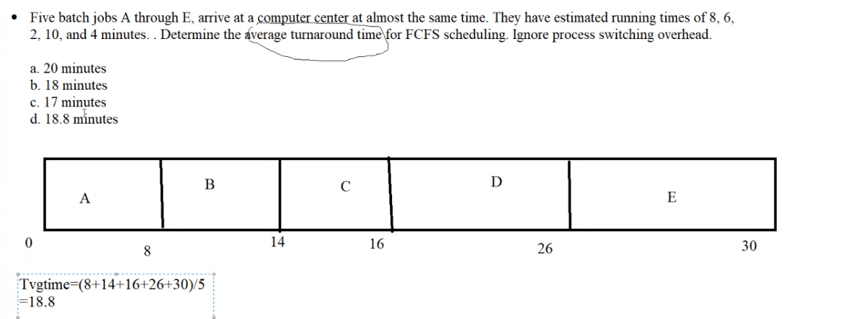

**Bai 2: thuat toan 2: SJF (Shortest Job First) tinh thoi gian cho trung binh**

* 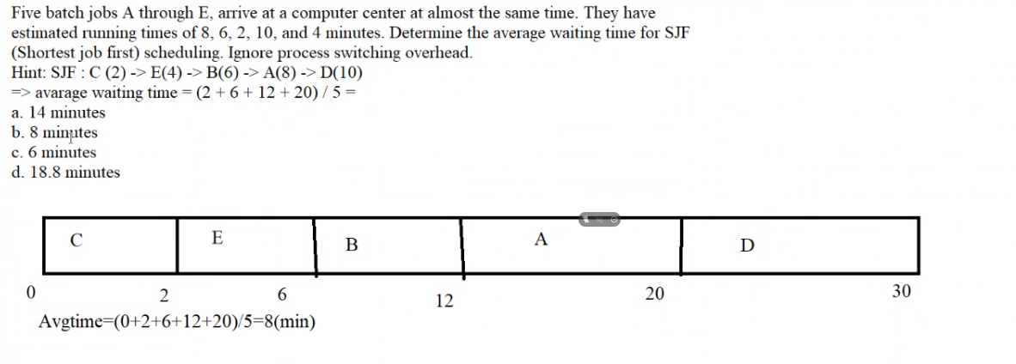

**Bai 2.b : Thuat toan SJF (shortest job first) :** Tinh thoi gian xoay vong tb (tg xu ly tb) va thoi gian cho tb:

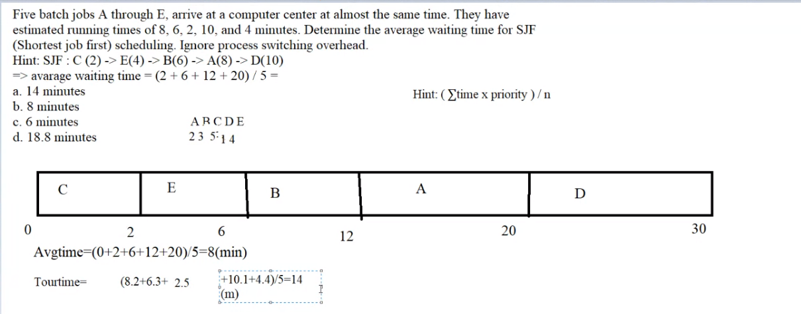

**Bai 3: Thuat toan 2:** tinh thoi gian cho trung binh

(uu tien cho tien trinh ngan nhat **SJF (Shortest Job First)**)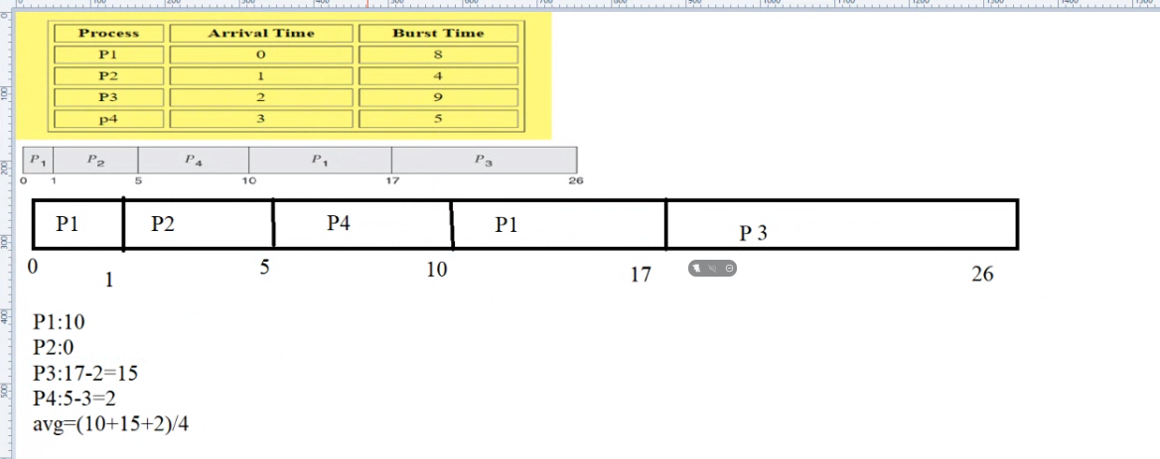

Bai 4:

**Thuat toan 3**: round robin

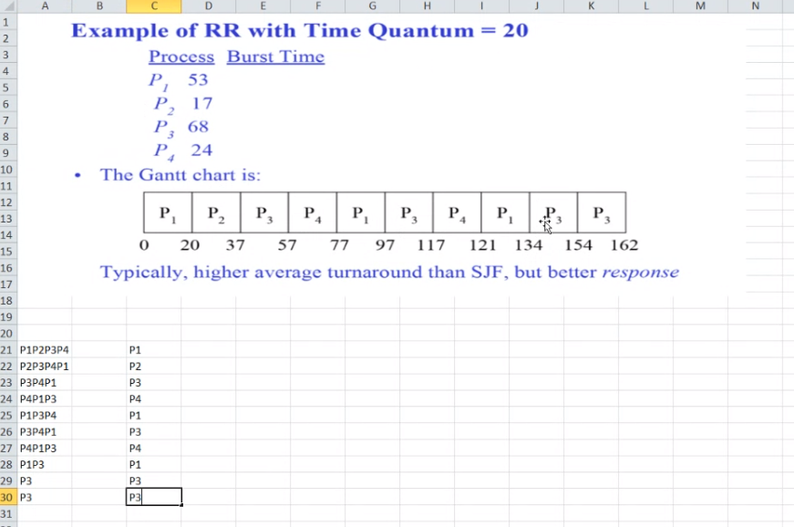

* Tg chờ tb =
* T xoay vòng tb ( thời gian xử lý tb) =

**Bai 5:** Tinh thoi gian xoay vong (thoi gian thuc hien) trung binh cho thuat toan uu tien theo chi so uu tien: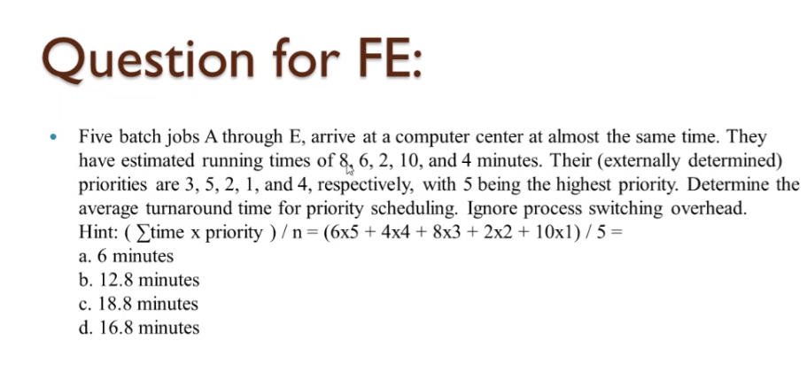

Bai tap: cho 5 tien trinh A…E voi thoi gian chay va do uu tien nhu trong bang, tinh AWT va ATT theo thuat toan uu tien va sortest first

|  |  |  |  |  |  |  |
| --- | --- | --- | --- | --- | --- | --- |
| **Thuat toan Priority** |  |  |  |  |  |  |
|  |  |  |  |  |  |  |
| Process | A | B | C | D | E |  |
| RUN | 8 | 6 | 2 | 10 | 4 |  |
| PRIORITI | 3 | 5 | 2 | 1 | 4 |  |
|  |  |  |  |  |  |  |
|  |  |  |  |  |  | 5 max |
| Order | B | E | A | C | D |  |
|  | 6 | 4 | 8 | 2 | 10 |  |
| Time 0 | 6 | 10 | 18 | 20 | 30 |  |
|  |  |  |  |  |  | **TB** |
| **Aravage waiting time** | **0** | **6** | **10** | **18** | **20** | **10.8** |
| Turn around time |  |  |  |  |  | **16.8** |
|  |  |  |  |  |  |  |
| **Neu theo thuat toan sortest first** | |  |  |  |  |  |
|  |  |  |  |  |  |  |
| Order | C | E | B | A | D |  |
|  | 2 | 4 | 6 | 8 | 10 |  |
| Time 0 | 2 | 6 | 12 | 20 | 30 |  |
|  |  |  |  |  |  | **TB** |
| **Aravage waiting time** | **0** | **2** | **6** | **12** | **20** | **8** |
| Turn around time |  |  |  |  |  | **14** |

|  |  |  |  |  |  |  |  |  |  |
| --- | --- | --- | --- | --- | --- | --- | --- | --- | --- |
| vua theo Priority vua theo round robin voi quan tum= 4 | | | |  |  |  |  |  |  |
|  |  |  |  |  |  |  |  |  |  |
|  |  |  |  |  |  |  |  |  |  |
| Order | B | E | A | C | D | B | A | D | D |
|  | 6 | 4 | 8 | 2 | 10 | 2 | 4 | 6 | 2 |
| Time 0 | 4 | 8 | 12 | 14 | 18 | 20 | 24 | 28 | 30 |
|  |  |  |  |  |  | **TB** |  |  |  |
| **Aravage waiting time** | **18** | **4** | **20** | **12** | **28** | **16.4** |  |  |  |
| A Turn around time | 20 | 8 | 24 | 14 | 30 | **19.2** |  |  |  |
|  |  |  |  |  |  |  |  |  |  |
|  |  |  |  |  |  |  |  |  |  |
| vua theo sortestfirst vua theo quantum=4 | | |  |  |  |  |  |  |  |
|  |  |  |  |  |  |  |  |  |  |
| Order | C | E | B | A | D | B | A | D | D |
|  | 2 | 4 | 6 | 8 | 10 | 2 | 4 | 6 | 2 |
| Time 0 | 2 | 6 | 10 | 14 | 18 | 20 | 24 | 28 | 30 |
|  |  |  |  |  |  | **TB** |  |  |  |
| **Aravage waiting time** | **0** | **2** | **18** | **20** | **28** | **13.6** |  |  |  |
| A Turn around time | 2 | 6 | 20 | 24 | 30 | **16.4** |  |  |  |

Bai tap ve kich thuoc bang

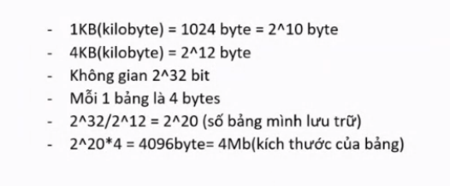

Bai tap ve kich thuoc dia chi nho

